As an aspiring clarinetist with a fascination for all types of clarinets or auxiliary clarinets, it would be imperative to study and research about the clarinet’s history including its close relative, the basset horn. As a relatively young instrument to the orchestra, the clarinet began its development around the later part of the 18th century. Early in its development, instrument makers would create and experiment with different shapes and sizes. As developers wanted bigger instruments, the technological inadequacies of the time influenced the designs of the larger clarinets, then called basset horns. Mozart, an influential and important composer, first heard clarinets most likely during his stay in London in 1764, in Milan in 1771, and Mannheim in 1777, but not in Salzburg because there were none in his home city. After hearing and discovering several virtuosi performing on the clarinet, the basset horn, and basset clarinet, Mozart became highly motivated and inspired to write numerous works involving these instruments. This project attempts to discuss and review all of the works that Mozart composed utilizing the basset horn and the basset clarinet.

K. 361 (370a) Serenade 'Gran Partita’
- AMA: IX/Sec. 1/No. 12, p. 399 [R23]
- NMA: VII/17/2, p. 141 [Pb 17] BA 5331; TP 312

Example 1: K. 361, Movement 1, mm. 1-3
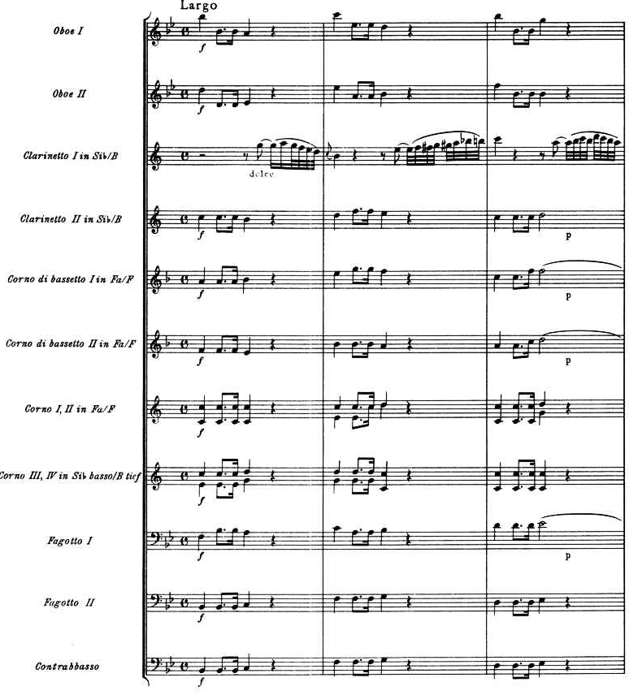

Example 2: K. 361 Movement 2, Menuetto: Trio 1
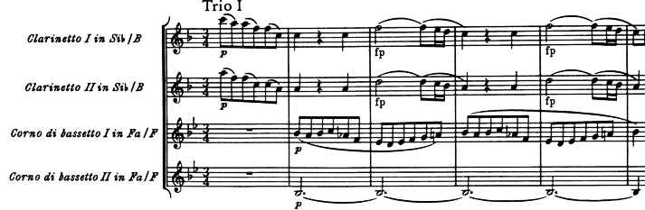

1st Movement: Largo-Molto allegro
2nd Movement: Menuetto
3rd Movement: Adagio
4th Movement: Menuetto; Allegretto
5th Movement: Romance; Adagio-Allegretto-Adagio
6th Movement: Tema con Variazioni; Andante
7th Movement: Finale; Molto allegro

Mozart’s K. 361 or K.³ 370a is a seven-movement serenade, or sometimes referred to as a “Harmonie ensemble” or Harmoniemusik, and is in B-flat-major for wind ensemble containing two oboes, two clarinets, two basset horns, four horns, two bassoons, and a double bass. The extra basset horns, horns, and double bass were an unusual addition to the normal eight-member chamber wind ensemble. This work is often performed nowadays with a contrabassoon instead of a double bass.
It is often called “gran Partitta” which is written on the manuscript, or the “Grand Partita” or “Gran Partita”. This subtitle has created some controversy because it is not written in Mozart’s hand and is a German-Italian non-standardized combination of words and grammar. The date of composition, along with why it was written and its commissioner are questionable and are long lost. The date of composition is either 1780-81 while Mozart was in Munich or was 1783-84 while Mozart was in Vienna. The compositional date of the work is under debate due to the watermark research resulting in a date of 1782. Mozart and his dog could have contributed to the reason why conflicting watermarks are noticed when they possibly knocked things around and mixed up his sheet music supply. This would have caused older paper to be used thus resulting in a dating error.
Whenever the date was, it was before 1784 because on March 23 of that year, four movements of the Serenade were premièred by Stadler and twelve other musicians at the National Hoftheater in Vienna and reviewed in the Winerblättchen newspaper. According to Daniel Leeson, he believes that “no one can definitively establish when it was written, what circumstances that led to its creation, or who might have commissioned it”.
Mozart could have possibly written it due to the influence of the great basset horn virtuosi David and Springer who were in Vienna at the time. On the other hand stylistic evidence suggests that it may have been written for Anton Stadler. Most likely the presence of four excellent clarinet and basset horn virtuosi must have inspired Mozart to write such a work. Anton Stadler’s playing and Mozart’s compositions were admired greatly and described in Johann Friedrich Schink’s memoirs. Schink describes Stadler as a “braver Virtuoso” due to his soft vocal qualities in tone to which no one with a good “heart could withstand.” If all four clarinetists were the inspiration, an interesting question arises in which who played what part. If Stadler played first then, it is likely David and Springer would have had to borrow Stadler’s basset horn, for the key was different and the range was greater than the horn they had could accommodate.
The work is full of rich sonorities that emote a feeling of breathlessness and intimacy in the concert hall. It is fitting that it closes Mozart’s great period of wind writing. The two basset horns play a pivotal role throughout the work and are often paired with the two clarinets, especially in the first trio of the first Menuetto (example 2). Mozart likes not only in this work, but in others to pair the basset horn with the oboes. Mozart’s use of thematic material that is dialogue in nature while contrasting between tutti and smaller groups, has allowed for a variety of instrumental combinations and is ultimately “kaleidoscopic writing… [which stands] without parallel in wind music” today.

Anh. 229 (K.² Anh. 229ª, K.⁶ 439b) fünfundzwanzig Stücke (fünf divertimenti)
- AMA: XXIV/11/No. 62, pp. 1, 8, 15, 25, 31, (2cl; bn) [R 40]
- NMA: VIII/21, p. 67, p. 78, p. 89, p. 105, p. 114 (also p. 167) [Pb 18]

Example 3: Anh. 229, No. 1, Movement 1, mm. 1-3
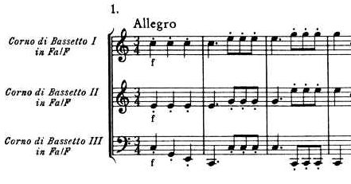

No. 1: Allegro, Menuetto: Allegretto, Adagio, Rondo; Allegro
No. 2: Allegro. Menuetto, Larghetto. Menuetto. Rondo; Allegro
No. 3: Allegro, Menuetto, Adagio, Menuetto, Rondo
No. 4: Allegro, Larghetto, Menuetto, Adagio, Allegro; Rondo
No. 5: Adagio, Menuetto, Adagio, Andante; Romance, Polonaise

Anhang 229, or K² Anhang 229a, K⁶ 439b also is an interesting work that has a controversial past. It is a collection of twenty-five pieces, in B-flat-major, that have been separated into five divertimenti for three basset horns. They have several different Köchel listings and names including K¹ listing only Divertimento II, K² listing as Anhang 229a, 3 Terzetti facili, and then finally K⁶ as 439b, 5 Divertimenti. They were allegedly composed between 1783 and 1788. These divertimenti have long been lost in their original form. Even in Mozart’s time it is believed that Constanze’s letter to the publisher André in May of 1800 claims that Stadler had in his suitcase some unknown trios for basset horns that were stolen or more acceptably believed, pawned among instruments and the manuscripts of other works possibly including the clarinet Concerto and Quintet for 73 ducats. A controversy arises because there are no original manuscripts, however, this collection of divertimenti were published in 1803 by Breitkopf and Härtel under Mozart’s name for two basset horns and bassoon, and later by Simrock for two clarinets and bassoon. It is widely believed that these divertimenti are the works in question that were lost by Stadler and have been generally accepted as composed for three basset horns and not with bassoon. The three basset horn approach makes more sense due to the fact that the upper clarinet parts and bassoon lower parts is too far apart and creates havoc in the harmonic structure. Mozart was also a fan of homogeneous instrumentation, which allows the pieces to sound better and coherent in timbre and sound with three basset horns.
It is unknown whether the divertimenti are supposed to be grouped the way they are published, since the first edition by Breitkopf and Härtel grouped them as five sets of divertimenti. It is also possible they could have been twenty-five pieces to be performed randomly. It is also unknown whether there is supposed to be a sixth set of five arrangements from Mozart’s operas that were also a part of the first published edition. Another controversy involves a dating error where the original Köchel catalogue included them at the end of the Notturni, K. 436-439, which are from 1783. Wyzema and Saint-Foix would then date these for 1786.
A further controversy involves whether these divertimenti are of Masonic influence. In the flowing lines of the multiple slow movements, a Masonic character is certainly applied and is comparable to the Adagio, K. 411. The slow second melodic line supports the march of the brothers, as they would proceed during an opening or closing of a Lodge. Melody interruptions by silences correspond precisely to the interruptions in the procession. Most likely these pieces were not intended to be performed for larger audiences but rather were probably intended as gifts to remain among friends and masonry brothers. Mozart probably would be delighted to know that these divertimenti are sometimes unearthed and performed in Lodges, as Mozart probably intended.

Martha Kingdom Ward, “Mozart and the Clarinet,” Music and Letters 28, no. 2 (April 1947): 126, http://www.jstor.org/stable/855526 (accessed April 20, 2009).
Mozart, Wolfgang Amadeus Mozart, NMA: III/9, 141, http://dme.mozarteum.at/DME/nma/nmapub_srch.php?l=2 (accessed Nov. 1, 2009).
Ibid.
Ibid., 165.
Stanley, Sadie. The New Grove: Mozart (New York: WW Norton, 1983), 99.
Daniel N. Leeson, gran Partitta: a book about Mozart’s Serenade in B-flat, K361 for 12 Wind Instruments and String Bass (Bloomington, IN: AuthorHouse, 2009), 51.
Ulrich Konrad, Mozart: Catologue of his Works, Trans. J. Bradford Robinson, (London: Bärenreiter 2006), 102-103.
Sadie. New Grove, 99.
Neal Zaslaw and William Cowdery ed., The Compleat Mozart: a Guide to the Musical Works of Wolfgang Amadeus Mozart, (New York: W. W. Norton, 1990), 248.
Leeson, gran Partitta, 41.
Sadie, New Grove, 76.
Zaslaw, Compleat, 248.
Leeson, gran Partitta, 20.
Zaslaw, Compleat, 248.
Leeson, gran Partitta, 13.
Ibid., 58.
Zaslaw, Compleat, 248.
Lawson, Mozart Concerto, 19.
Zaslaw, Compleat, 248.
Rendall, Clarinet, 82.
Newhill, Basset Horn, 95.
Zaslaw, Compleat, 248.
Sadie, New Grove, 99.
Mozart, NMA: VIII/21, 67.
Ibid.
Konrad, Mozart, 102-103.
Pamela L. Poulin, “A Report on New Information Regarding Stadler’s Concert Tour of Europe and Two Early Examples of the Basset Clarinet” in Bericht über den Internationalen Mozart-Krongreß Salzburg 1991, (New York: Bärenreiter, 1992), 950.
Zaslaw, Compleat, 247.
Newhill, Basset Horn, 76.
Trio di Clarone, “Forward” in Five Divertimenti for Three Basset Horns by Wolfgang Amadeus Mozart, (Wedemark/Iffezheim: Breitkopf and Härtel, 1987).
Henry, Mozart the Freemason, 39.
Ibid., 40.
Ibid., 39-40.

