In 1783, Wolfgang Amadeus Mozart would forever change the musical world, as he developed a “love affair” with the basset horn. After moving to Vienna, entering into Freemasonry, and becoming inspired by some of the greatest virtuosi, Mozart was able to conceive and express some of his most creative and spiritually enlightened music. The nature of the instrument with its particular tone and vocal qualities is what attracted Mozart’s affection. This affection for the instrument combined with Mozart’s Masonic inspirations and symbolism is what caused the basset horn to be regarded as a ritualistic and Masonic instrument.
During his first two years of brotherhood, Mozart composed twelve pieces utilizing the basset horn, and overall in his last decade of life, Mozart would include the instrument in some twenty-five works. They all have since become some of Mozart’s most lasting and inspiring works performed and discussed through the centuries. In all of these works, the basset horn contains a significant role, and Mozart’s writing is very idiomatic of the instrument. Not only did Mozart significantly employ the basset horns as a vessel for his Masonic symbols and ideals, but the basset horn itself can also be regarded as a Masonic symbol.

Official Masonic Works
Two pieces regarded as official Masonic works utilizing basset horns where Masonic symbolism is present are the two Adagios, K. 410 and K. 411. Both are included on some official Masonic works lists as to be authenticated by the Freemasonry order. The famous Mozart researcher Alfred Einstein supports this idea by arguing that they do indeed represent Masonic mood and purpose. Both are composed around 1783 or 1784 and are described as works using “columns of harmony” where instruments are linked by their nature to breath and life.
The Canonic Adagio, K. 410 contains several Masonic symbols. It is for scored for three instruments, two basset horns and bassoon. It is F-major and represents the first degree, or Entered Apprentice of freemasonry. The basset horns present a quiet and calming contrapuntal line over a moving and pointed bass line. In figure 1, note that the second measure also contains the Masonic dotted rhythm and the third measure contains basset horns in thirds with the rest of the piece is filled being filled with numerous symbols. All of these musical symbols, the slurs, dissonant seconds, harmonious thirds and sixths all create sounds of joy, love, and represent ties of brotherhood.

Figure 1. K. 410, mm. 1-4.
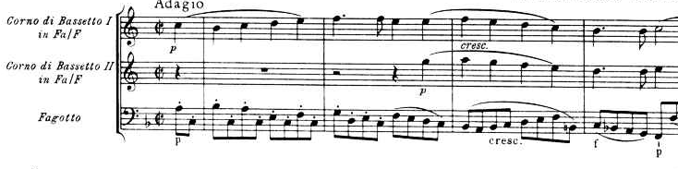

The companion to K 410 is the Adagio, K. 411 and is probably the best piece utilizing the basset horn as a Masonic symbol. It incorporates two clarinets and three basset horns, and is in Bb-major, which represents the second degree, or the Journeyman or Fellow Craft degree. It is processional in nature and is thought of as a ritual march to bring the sacred to the assembly. The opening measure is filled with numerous symbolic elements (see fig. 2), including the dotted quarter with three eighths rhythm representing the three Masonic “knocks”. The bass line rises with a dotted rhythm on a major chord representing the rising up from darkness to light theme. A very powerful musical moment happens in the second theme (see fig. 3) where each entrance of an instrument builds in intensity with dissonant seconds over an ostinato bass line that create a tremendous musical moment when resolved into perfect harmony. This moment in the music effectively instills the ideas of moving from the dissonant darkness to the tonally pure light and creates a powerful bond of brotherhood.
Figure 2. K. 411, mm. 1-8.
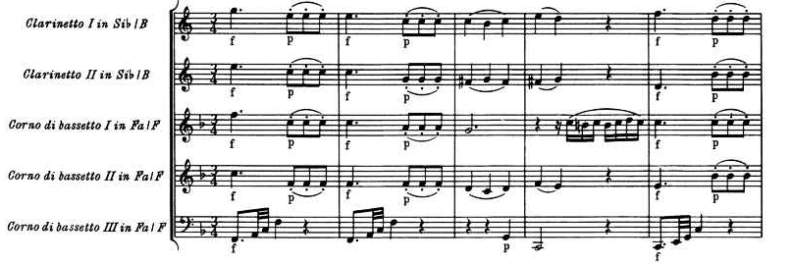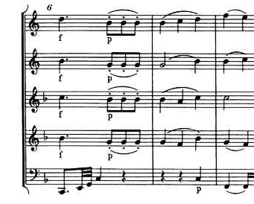

Figure 3. K. 411 mm. 17-22.
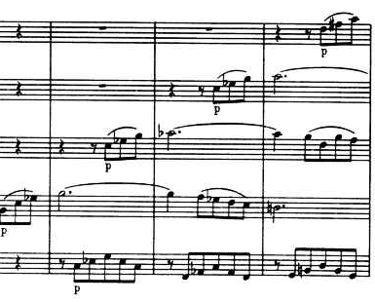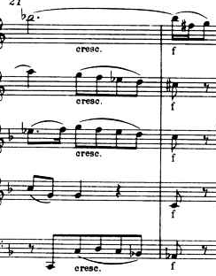

1. Colin Lawson, Mozart: Clarinet Concerto (New York: Cambridge University Press, 1996), 19.
. For more information on Mozart and Masonry, see Jacques Henry, Mozart the Freemason: The Masonic Influence on his Musical Genius, Trans. Jack Cain (Rochester, Vermont: Inner Traditions, 2006).
. K. 361 Serenade Gran Partita, K. 384 Die Entfürung aus dem Serail, K. 410 and K. 411 Adagios, K. 346, K. 436, K. 437, K. 438, K. 439, K. 549 Vocal Notturni and Canzonetta, K. 477 Maurerische Trauermusik, K. 487 12 Duos, K. 577 Le Nozze di Figaro aria “Al desio di chi t'adora”, K. 621b Concerto fragment, K. 620 Die Zauberflöte, K. 621 La Clemenza di Tito, K. 626 Requiem, K. 439b, and seven other unfinished fragments
. Henry, Mozart the Freemason, 123-124.
. The Cambridge Mozart Encyclopedia (New York: Cambridge University Press, 2007), sv. “freemasonry.”
. Henry, Mozart the Freemason, 19.
. Henry, Mozart the Freemason, 28.
. Mozart, NMA: VIII/21, http://dme.mozarteum.at/DME/nma/nmapub_srch.php?l=2 (accessed Nov. 1, 2010), 120.
. Henry, Mozart the Freemason, 92.
. Mozart, NMA: VII/17/2, 223.
. Mozart, NMA: VII/17/2, 224.

